Technical Design

MyBuddy!

Learning unit: MyBuddy! (App) BT1

Version number: 0.1

Author(s): Cody Strijbosch

# Version Control

|  |  |  |  |
| --- | --- | --- | --- |
| Date | Version | Changes | Who |
| 17-5-2017 | 0.1 | - | Cody Strijbosch |
|  |  |  |  |
|  |  |  |  |

# Contents list

Versiebeheer

Inhoudsopgave

Inleiding

Planning

Software architectuur

Applicatie flow

User Interface Design

Database/Gegevens/Content

Applicatie opbouw

Akkoord leidinggevende/Projectleider

# Introduction

The goal of this document is to get an understanding about the different techniques that are going to be used at developing the desired software. Besides that there will be a clear image drawn about the different techniques that are connected to each other. This document is made for this project so everyone that gets involved will find it easier to find his way in the already existing architecture and software functions.

The project is an app for RijnIJssel students to plan a memory so they don’t miss any important appointments. The project will be made with html, css, php, bootstrap and a database.

# Schedule

For this document I planned a time limit of 6-10 hours because it’s the first time I make this document.

Software architecture

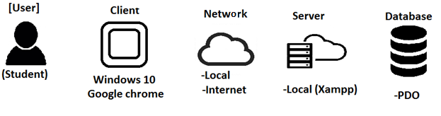

Application Flow

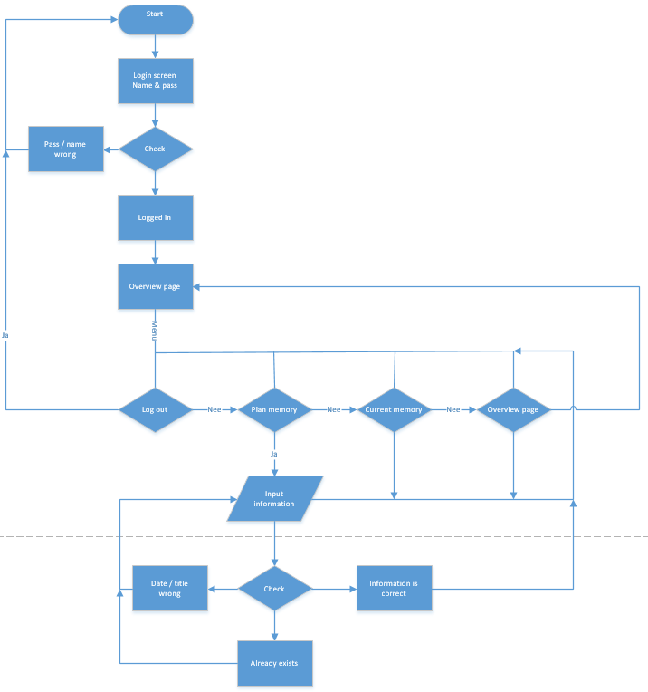

Activity Diagrams

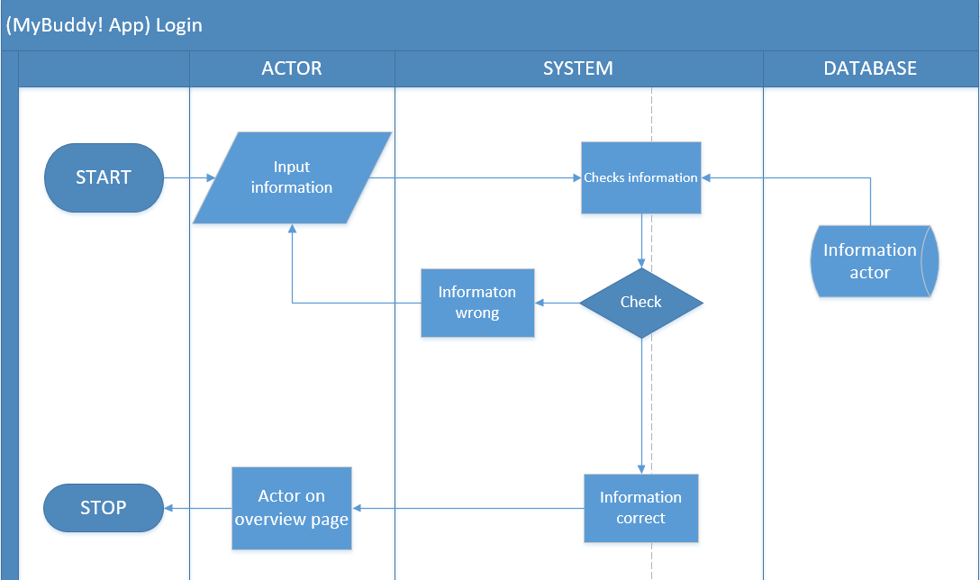

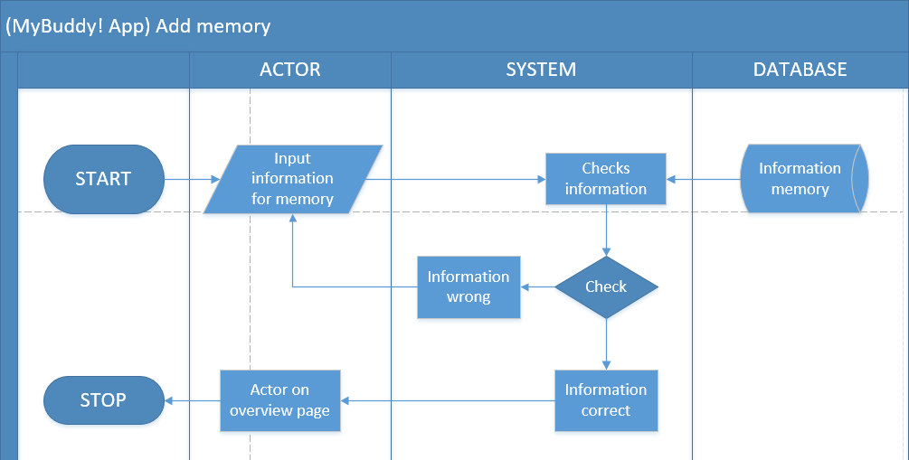

User Interface Design

The user interface design will be added after the application/app has been made.

Database/Information/Content

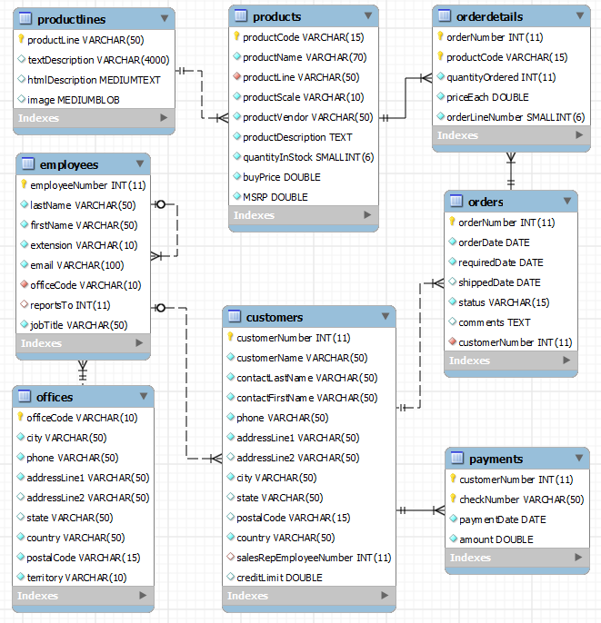

The database content will be added after the application/app has been made.

Gegevens:

There will be no external files added to let this application function properly. All the information that will be put in the database comes from user input.

Application structure

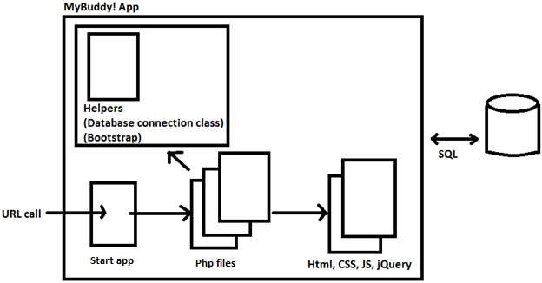

# 

# Akkoord leidinggevende/Projectleider

|  |  |
| --- | --- |
| Naam |  |
| Datum |  |
| Handtekening |  |